LINUX SYSTEM DIAGNOSTICS TOOLKIT
A Project Based Learning Report Submitted in partial fulfilment of the requirements for the award of the degree

of

Bachelor of Technology
in The Department of Artificial Intelligence and Data Science
OPERATING SYSTEMS AND SYSTEMS PROGRAMMING – 25CS2104E
Submitted by
2510080029 : O.Sudeeptha
2510080037 : Lokrey Latika
2510080043 : Sai Siri
2510080061 : M.Kovidha

Under the guidance of
Dr. P. Kalpana


Department of Artificial Intelligence and Data Science
Koneru Lakshmaiah Education Foundation, Aziz Nagar
Aziz Nagar – 500075
JULY - 2026

Abstract

The Linux System Diagnostics Toolkit is a command-line application developed in the C programming language to provide basic system information and support Linux command execution. The project aims to simplify access to common diagnostic operations through a single terminal-based interface.

The toolkit includes command parsing, built-in commands, process creation, signal handling, inter-process communication through pipes, and input/output redirection. It supports commands such as uptime, memory, pwd, cd, help, and env, along with external Linux utilities. POSIX threads are used to implement a background monitoring task.

The application is organized into modular source and header files to improve readability, maintainability, and future extensibility. A Makefile is used to compile the project and build its executable programs. Additional experimental programs demonstrate deadlock conditions and a consistent-lock-ordering approach to deadlock prevention.

The project provides practical experience with Linux system calls, process management, memory handling, signals, pipes, file descriptors, multithreading, and debugging. Some advanced job-control features require further testing and refinement.

List of Figures

Figure No. | Figure Title | Page No.
Figure 2.1 | Workflow of Linux System Diagnostics Toolkit | 10
Figure 2.2 | Modular Architecture of Linux System Diagnostics Toolkit | 11
Figure 2.3 | Flowchart of the Command Execution Process | 12
Figure 3.1 | Toolkit Startup Interface | 14
Figure 3.2 | Command Parsing and Help Output | 15
Figure 3.3 | System Uptime Output | 16
Figure 3.4 | Memory Information Output | 16
Figure 3.5 | External Linux Command Execution | 16
Figure 3.6 | Pipe Execution | 17
Figure 3.7 | Output Redirection to a File | 17
Figure 3.8 | Background Monitoring Thread | 18
Figure 3.9 | Job-Control Test Output | 18
Figure 3.10 | Deadlock Demonstration Output | 18
Figure 3.11 | Successful Deadlock Prevention Output | 19
Figure 3.12 | Successful Compilation Using Makefile | 20

List of Tables

Table No. | Table Title | Page No.
Table 1.1 | Project Modules | 8
Table 2.1 | Software Tools and Development Environment | 13
Table 3.1 | Modules and Their Responsibilities | 23
Table 3.2 | Test Cases and Testing Results | 26

Table of Contents

S. No. | Contents | Page No.
1 | Abstract | 2
2 | List of Figures | 3
3 | List of Tables | 4
4 | Chapter 1: Introduction | 6
4.1 | Introduction | 6
4.2 | Problem Statement | 6
4.3 | Objectives | 7
4.4 | Project Modules | 7
4.5 | Motivation | 9
5 | Chapter 2: Methodology | 10
5.1 | System Workflow | 10
5.2 | System Architecture | 10
5.3 | Command Processing Methodology | 11
5.4 | Error Handling and Resource Management | 12
6 | Chapter 3: Implementation | 13
6.1 | Software Requirements | 13
6.2 | Hardware Requirements | 14
6.3 | Main Module | 14
6.4 | Command Parsing | 15
6.5 | System Diagnostics | 15
6.6 | Process Management | 16
6.7 | Pipes and Inter-Process Communication | 16
6.8 | File Descriptors and I/O Redirection | 17
6.9 | POSIX Thread Support | 17
6.10 | Job Control and Deadlock Examples | 18
6.11 | Makefile and Build Management | 19
6.12 | Environment and Built-in Command Support | 20
6.13 | Deadlock Demonstration | 21
6.14 | Deadlock Prevention | 22
7 | Chapter 4: System Design Details | 23
7.1 | Module Description | 23
7.2 | Important System Calls | 23
7.3 | Process Creation and Execution | 24
7.4 | Pipes and File Descriptors | 24
7.5 | Multithreading and Synchronization | 25
8 | Chapter 5: Results and Discussion | 26
8.1 | Results Obtained | 26
8.2 | Testing Results | 26
8.3 | Discussion | 27
8.4 | Limitations | 27
8.5 | Learning Outcomes | 27
9 | Chapter 6: Conclusion and Future Scope | 29
9.1 | Conclusion | 29
9.2 | Future Scope | 29
10 | References | 30

LINUX SYSTEM DIAGNOSTICS TOOLKIT

Chapter 1 : Introduction

Introduction

Linux provides several command-line utilities for inspecting system resources and performing administrative operations. However, users often need to execute multiple commands separately to obtain information about system uptime, memory utilization, files, processes, and other system details.

The Linux System Diagnostics Toolkit is designed to provide a simple command-line interface that combines basic diagnostic operations with external Linux command execution. It is developed using C and Linux system programming concepts.

The project follows a modular design in which input handling, command parsing, process execution, signal handling, pipes, redirection, and monitoring are implemented in separate modules. This structure makes the application easier to understand, maintain, and extend.

Problem Statement

Accessing system information often requires users to execute different commands and understand their individual outputs. Beginners may find it difficult to understand how these utilities interact with Linux processes and system calls.

The project addresses this learning and usability problem by providing a unified command-line toolkit that integrates basic diagnostics and command execution while demonstrating fundamental Linux operating system concepts.

Ojectives

The major objectives of the project are:
- To develop a command-line diagnostics application using C.
- To display basic system information such as uptime and memory details.
- To implement command parsing and built-in command execution.
- To execute external Linux commands using process-management system calls.
- To implement signal handling and process synchronization.
- To support pipelines and output redirection.
- To introduce multithreading using POSIX threads.
- To explore job control, mutex synchronization, and deadlock prevention.
- To organize the source code into reusable modules.
- To use a Makefile for compilation and build management.

Project Modules

The Linux System Diagnostics Toolkit is divided into modules, each responsible for a specific operation. This modular design improves code organization, simplifies debugging, and makes future extensions easier. The main module coordinates the application, while supporting modules manage input, parsing, diagnostics, process execution, signals, communication, file operations, and monitoring.

The project also contains experimental modules for job control and deadlock prevention. These modules demonstrate advanced operating-system concepts and require appropriate testing before all their functionality can be considered reliable.

The major modules of the project are described below.

Module | Description
Input Handling | Reads user input from the command-line interface.
Command Parser | Tokenizes user commands and separates commands from their arguments.
System Diagnostics | Retrieves and displays system information such as uptime and memory details.
Process Management | Creates child processes and executes external Linux commands using system calls.
Built-in Commands | Implements commands such as help, pwd, cd, env, clear, and exit.
Signal Handling | Handles signals such as SIGINT for improved process control.
Pipes and IPC | Enables communication between processes using pipes and file descriptor redirection.
I/O Redirection | Redirects command output to files using > and >>.
Thread Monitoring | Uses POSIX threads to perform background monitoring tasks.
Job Control | Explores foreground and background job management through job tracking and process control.
Deadlock Demonstration | Demonstrates deadlock conditions involving threads and mutex locks.
Deadlock Prevention | Demonstrates consistent mutex-lock ordering to prevent deadlocks.
Table 1.1: Project Modules

Motivation

Linux is widely used in software development, server administration, cloud computing, and embedded systems. Understanding system behavior is important for identifying resource-related problems and learning how an operating system manages processes, memory, and communication between programs.
The motivation for developing the Linux System Diagnostics Toolkit is to create a simple utility that combines basic diagnostic commands with practical demonstrations of Linux system programming. Instead of implementing each operation as an independent program, the toolkit provides a common command-line interface.
The project also provides an opportunity to understand how applications interact with the operating system through system calls. Concepts such as process creation, signal handling, pipes, file descriptors, and multithreading are explored through practical implementation in C.

Chapter 2 : Methodology

2.1 System Workflow

The toolkit follows a command-processing workflow. The application initializes its signal-handling and monitoring components and displays a command prompt. User input is read and passed to the parser, which separates the command and its arguments.

The command processor identifies whether the input is a built-in command, a diagnostic operation, a command requiring a pipe, or an external Linux command. External commands are executed through process creation and program execution. Pipes and redirection are handled by their respective modules.

The output is displayed in the terminal or redirected to a file, depending on the command. The application then returns to the command prompt for the next operation.
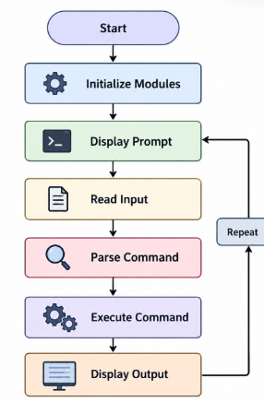
Figure 2.1: Workflow of Linux System Diagnostics Toolkit

2.2 System Architecture

The toolkit uses a modular architecture consisting of independent C source files and corresponding header files. The main module coordinates command input and execution, while specialized modules implement parsing, diagnostics, process management, built-in commands, signals, pipes, redirection, and monitoring.

The Makefile combines the required source files and compiler options to generate the main executable. Separate build targets are provided for the deadlock demonstration and prevention programs.
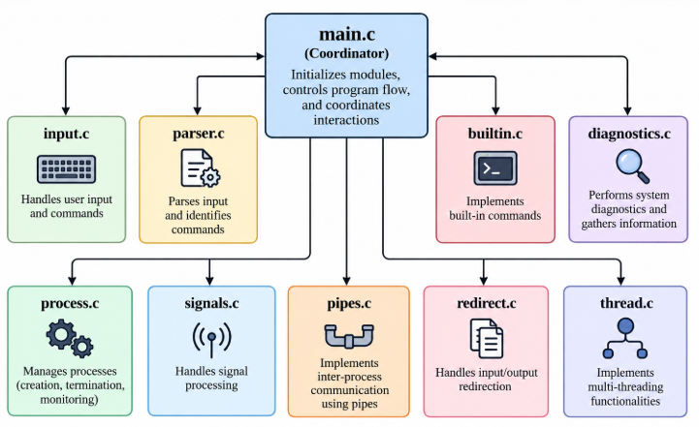
Figure 2.2: Modular Architecture of Linux System Diagnostics Toolkit

2.3 Command Processing Methodology

The command-processing methodology begins when the application displays the command prompt and waits for user input. The input module reads the command line and passes it to the parser. The parser separates the command name and its arguments into tokens that can be processed by the application.

After parsing, the main module identifies the type of command. Built-in commands are handled internally, diagnostic commands invoke the corresponding diagnostic functions, and external commands are executed using process-management operations. Commands containing pipes or output-redirection operators are routed through their respective modules.

Once execution is complete, the application releases temporary memory allocated for token processing and returns to the command prompt. This repeated workflow allows users to perform multiple operations in a single session.

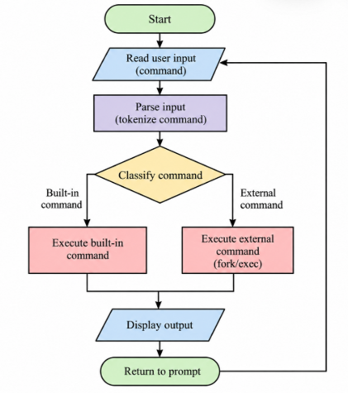
Figure 2.3: Flowchart of the Command Execution Process

2.4 Error Handling And Resource Management

Error handling is an important part of system programming because operations such as memory allocation, process creation, file access, and pipe creation may fail. The toolkit uses error-checking mechanisms to identify failures and report relevant messages where implemented.

Dynamic memory allocated for command tokens must be released after use. File descriptors opened during redirection must be closed when they are no longer needed. Parent processes must also handle child-process completion appropriately. These practices help reduce resource leaks and improve application stability.
Further testing is required to ensure that all error conditions, interrupted system calls, and concurrent process-state changes are handled correctly.

Chapter 3 : Implementation

3.1 Software Requirements

S. No. | Software/Tool | Purpose
1 | Ubuntu / WSL | Linux development environment
2 | GCC | C compiler
3 | GNU Make | Build automation
4 | Visual Studio Code or Terminal Editor | Source-code editing
5 | Git and GitHub | Version control
6 | GDB | Debugging
7 | Valgrind | Memory analysis, if used
Table 2.1: Software Tools and Development Environment

3.2 Hardware Requirements

The project can be developed on a computer capable of running Ubuntu or Windows Subsystem for Linux (WSL). A standard modern processor, sufficient RAM to run the development environment, and enough storage for the compiler, source files, and development tools are required. The exact specifications should be filled in according to the system used during development.

3.3 Main Module

The main module coordinates the operation of the toolkit. It initializes the required components, displays the command prompt, reads user input, invokes the parser, and dispatches commands to the appropriate module. It also handles the command-processing loop and memory cleanup after each command.

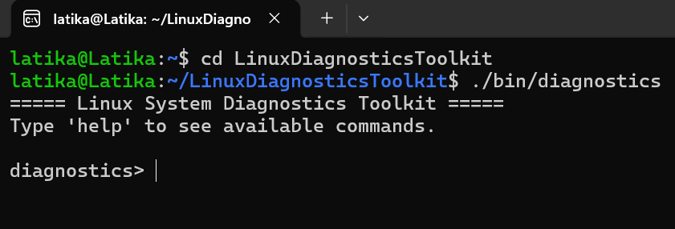
Figure 3.1: Toolkit Startup Interface

3.4 Command Parsing

The parser module converts user input into individual command tokens using string-tokenization functions. These tokens are passed to the command processor for built-in command handling, diagnostic operations, and external program execution.

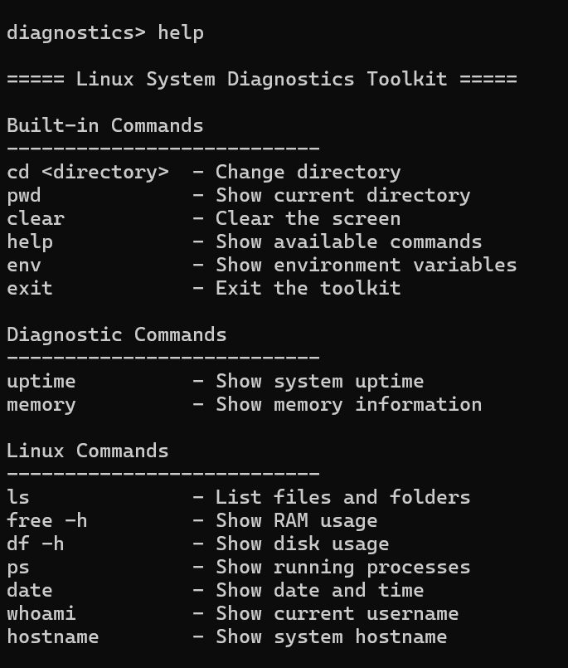
Figure 3.2: Command Parsing and Help Output

3.5 System Diagnostics

The diagnostics module provides access to basic system information, including system uptime and memory details. These functions allow users to inspect selected system information directly through the toolkit.

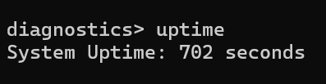
Figure 3.3: System Uptime Output

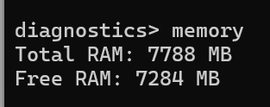
Figure 3.4: Memory Information Output

3.6 Process Management

The process-management functionality demonstrates process creation and external command execution. The project uses fork() to create child processes, execvp() to execute external programs, and waitpid() to synchronize the parent process with child-process execution. Error handling is provided for process-related operations.

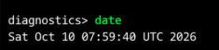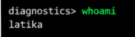
Figure 3.5: External Linux Command Execution

3.7 Pipes And Inter-Process Communication

The pipe module demonstrates communication between processes using anonymous pipes. The pipe() system call creates a communication channel, while dup2() redirects standard input or output to the appropriate file descriptor. Child processes execute the commands on either side of the pipeline.

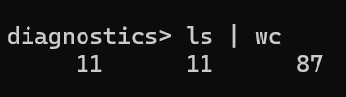
Figure 3.6: Pipe Execution

3.8 File Descriptors And I//O Redirection

The redirection module supports saving command output to files. The > operator is used for output redirection, while >> appends output to an existing file. File descriptors are managed using system calls such as open(), close(), and dup2().

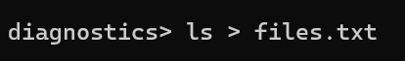
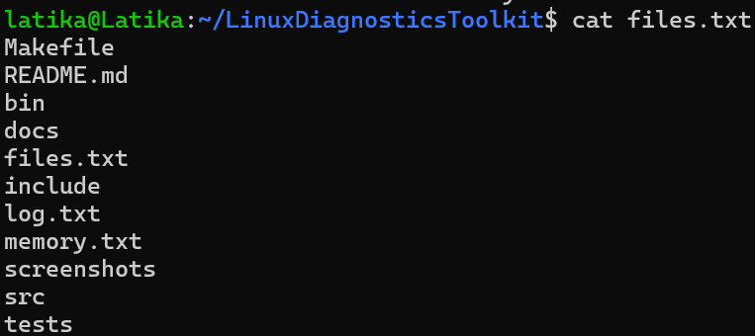
Figure 3.7: Output Redirection to a File what to display

3.9 POSIX Thread Support

The project includes a separate thread module that uses POSIX thread functionality. The monitoring thread periodically displays a status message indicating that the toolkit is running. This module demonstrates the use of multithreading and background activity in a C application.

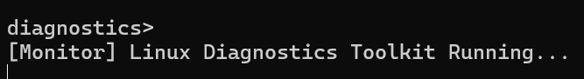
Figure 3.8: Background Monitoring Thread

3.10 Job Control And Deadlock Examples

Additional modules explore foreground and background process management through job tracking and job-control commands. Separate programs demonstrate deadlock using POSIX threads and mutexes, along with a prevention approach that acquires locks in a consistent order.
These advanced components are still being tested and refined. Their behaviour should be documented according to the results observed during testing.

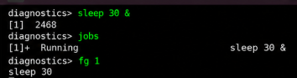
Figure 3.9: Job-Control Test Output

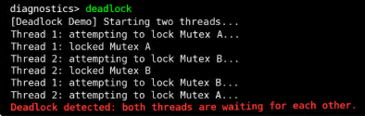
Figure 3.10: Deadlock Demonstration Output

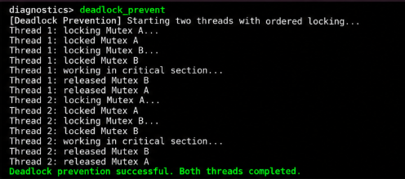
Figure 3.11: Successful Deadlock Prevention Output

3.11 Makefile And Build Management

The Makefile automates compilation of the toolkit and its supporting programs. It specifies the compiler, compilation flags, source files, and output executable names. The -Wall and -Wextra options enable additional compiler warnings, while -g includes debugging information useful during program analysis.

The -pthread option enables compilation and linking support for POSIX thread functionality. Separate build targets are provided for the main diagnostics application, the deadlock demonstration, and the deadlock-prevention example. A clean target removes generated binaries so that the application can be rebuilt when required.
This approach reduces repetitive compilation commands and provides a consistent build procedure for the project.

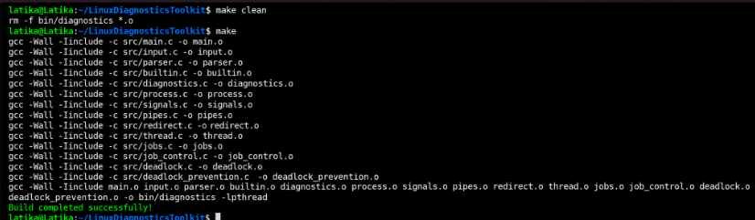
Figure 3.9: Terminal screenshot showing make clean followed by make completing successfully.

3.12 Environment And Built-in Command Support

Built-in commands are processed within the toolkit rather than being executed as independent external programs. The pwd command displays the current working directory, while cd changes the directory of the running toolkit process. The help command lists available commands, and env displays selected environment variables.

The clear command clears the terminal display, while exit terminates the application. Keeping these operations in a separate built-in command module makes command processing easier to maintain and allows the main program to distinguish internal operations from external Linux utilities.
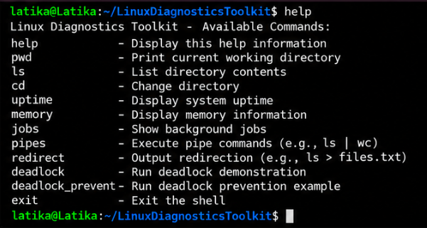
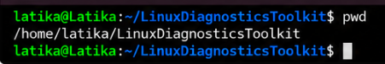
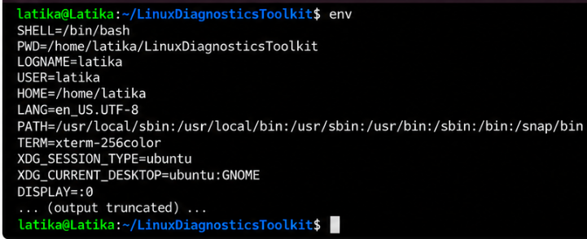
Figure 3.10: Screenshot showing help, pwd, and env outputs.

3.13 Deadlock Demonstration

Deadlock is a condition in which two or more threads wait indefinitely for resources held by one another. In the demonstration program, two mutex locks are used to represent shared resources. One thread acquires the first mutex and then requests the second, while another thread acquires the second mutex and then requests the first.
If both threads acquire their initial locks before requesting the other lock, each may wait indefinitely. This experiment illustrates circular waiting and the importance of consistent synchronization strategies in concurrent programs.

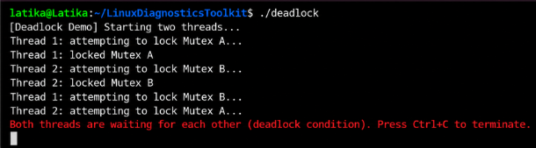
Figure 3.11: Screenshot of the deadlock demonstration while it is waiting.

3.13 Deadlock Prevention

The deadlock-prevention example uses a consistent order when acquiring mutex locks. Both threads request the shared locks in the same order rather than acquiring them in opposite orders.
Consistent lock ordering prevents the circular-wait condition illustrated by the deadlock demonstration. This approach is a practical example of how synchronization design can reduce the risk of deadlocks in multithreaded applications.

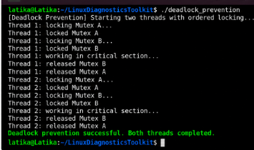
Figure 3.12: Screenshot of the prevention program completing successfully.

Chapter 4 : System Design Details

Instead of the recruitment template's database schema, use this chapter for your module design and system-call details.

4.1 Module Description

Module | Responsibility
main.c | Main command loop and command dispatch
input.c | User input handling
parser.c | Command tokenization
builtin.c | Built-in commands
diagnostics.c | Uptime and memory information
process.c | Process execution
signals.c | Signal handling
pipes.c | Pipe-based communication
redirect.c | Output redirection
thread.c | Background monitoring
jobs.c and job_control.c | Job tracking and process control; testing required
deadlock.c | Deadlock demonstration
deadlock_prevention.c | Consistent lock-ordering example

Table 3.1: Modules and Their Responsibilities

4.2 Important System Calls

The project uses Linux and POSIX interfaces to demonstrate operating system functionality. fork() creates a child process, execvp() executes an external program, and waitpid() waits for child-process state changes. pipe() creates a communication channel between processes, while dup2() redirects file descriptors.

The open() and close() calls are used in file operations. Signal-handling functions manage selected signals, while POSIX thread and mutex functions demonstrate multithreading and synchronization concepts.

4.3 Process Creation And Execution

The toolkit demonstrates process creation using fork(). When a new process is created, the child process can execute a Linux utility through execvp(). The parent process uses waitpid() when synchronization with child-process completion is required.

This separation between parent and child processes demonstrates how operating systems support concurrent program execution. Error handling is necessary because process creation and program execution can fail due to resource limitations or invalid commands.

Process groups and terminal foreground ownership are also explored in the job-control module. Reliable job tracking requires careful coordination between process-state changes and the functions that wait for child processes.

4.4 Pipes And File Descriptors

Pipes provide a communication channel between processes. In a two-command pipeline, the first command produces output that is connected to the input of the second command. The dup2() system call redirects the appropriate standard file descriptor so that the commands can exchange data through the pipe.

File descriptors are also used in output redirection. The output of a command can be directed to a file rather than displayed on the terminal. These operations demonstrate the relationship between process execution, standard input, standard output, and the Linux file-descriptor interface.

4.5 Multithreading And Synchronization

POSIX threads allow multiple threads of execution to exist within a single process. The monitoring module uses a separate thread to perform periodic status reporting while the main thread accepts commands.

The deadlock examples extend this concept by using mutexes to coordinate access to shared resources. They illustrate why synchronization order matters and why concurrent programs must be designed to avoid indefinite waiting conditions.
Concurrent terminal output can overlap with the command prompt, so a more advanced implementation could use controlled logging or a user-requested monitoring command to improve readability.

Chapter 5 : Results And Discussion

5.1 Results Obtained

The toolkit has been developed as a modular C application that integrates command parsing, built-in commands, external Linux command execution, diagnostic operations, pipes, output redirection, and background monitoring.

The project demonstrates the use of process creation, process synchronization, file descriptors, signals, and POSIX threads. Separate programs have also been created to study deadlock and a consistent-lock-ordering prevention technique.

The results of each feature are evaluated through compilation and command-execution tests. Features that are still being debugged are identified separately and are not considered fully verified.

5.2 Testing Results

Test Case | Expected Result | Status
make | Successful compilation | Pass/Fail
help | Displays help information | Pass/Fail
pwd | Prints current directory | Pass/Fail
uptime | Displays system uptime | Pass/Fail
memory | Displays memory information | Pass/Fail
ls \| wc | Executes a pipeline | Pass/Fail
ls > files.txt | Saves output to a file | Pass/Fail
Monitoring thread | Displays periodic status | Pass/Fail
Background jobs | Tracks jobs correctly | Pass/Fail/In Progress
Deadlock prevention | Completes without deadlock | Pass/Fail

Table 3.2: Test Cases and Testing Results

5.3 Discussion

The project demonstrates how Linux system calls and modular C programming can be combined to build a command-line system utility. The separate modules help organize responsibilities and make future development easier.

Testing also highlights the importance of correct command parsing, child-process synchronization, signal management, and thread coordination. Additional debugging and validation are required for advanced job-control behavior before it can be considered reliable.

5.4 Limitations

The current project provides a foundation for basic diagnostics and Linux system programming, but it has several limitations. System information is presented primarily as terminal output rather than through a graphical dashboard or structured report.

The monitoring module produces status messages but does not yet provide comprehensive resource analytics. Advanced job-control functionality also requires additional debugging and testing to ensure correct handling of background processes, foreground ownership, and child-process status changes.

The toolkit can be extended with improved input validation, more detailed CPU and network measurements, structured logging, and automated test cases.

5.4 Learning Outcomes

The project provides practical experience in modular C programming, dynamic memory management, command parsing, and Linux process execution. It demonstrates how system calls can be combined to implement pipes, output redirection, signal handling, and process synchronization.
The use of POSIX threads introduces multithreading and background activity, while the deadlock programs demonstrate resource contention and lock-ordering strategies. The build process and debugging activities also provide experience with compiler warnings, Makefiles, and systematic troubleshooting.

These concepts establish a foundation for developing more advanced Linux utilities and system-monitoring applications.

Chapter 6 : Conclusion And Future Scope

6.1 Conclusion

The Linux System Diagnostics Toolkit provides a practical implementation of Linux system programming concepts in C. It integrates basic system diagnostics with command parsing, built-in commands, external command execution, pipes, file redirection, and background monitoring.

The project provides experience with process creation, system calls, signals, file descriptors, multithreading, and synchronization. Its modular architecture provides a foundation for further improvements in diagnostic functionality, reliability, and reporting.

6.2 Future Scope

Future enhancements may include:
- CPU utilization monitoring.
- Detailed disk and network diagnostics.
- Process monitoring and resource analysis.
- Reliable foreground and background job control.
- Improved signal and thread coordination.
- Automated health checks and alerts.
- Exporting diagnostic information to text, HTML, or PDF reports.
- Structured logs and scheduled monitoring.
- A graphical or web-based monitoring dashboard.

Reference

- GNU Compiler Collection (GCC) Documentation. https://gcc.gnu.org/onlinedocs/
- GNU Make Manual. https://www.gnu.org/software/make/manual/
- Linux man-pages project. https://man7.org/linux/man-pages/
- The Open Group, POSIX specifications. https://pubs.opengroup.org/onlinepubs/9699919799/
- GNU Debugger (GDB) Documentation. https://www.sourceware.org/gdb/documentation/
- Valgrind Documentation. https://valgrind.org/docs/manual/

